DRAWING GRAPHS
Pearson Edexcel – Thursday 4 June 2020 - Paper 2 (Calculator) Higher Tier
1.
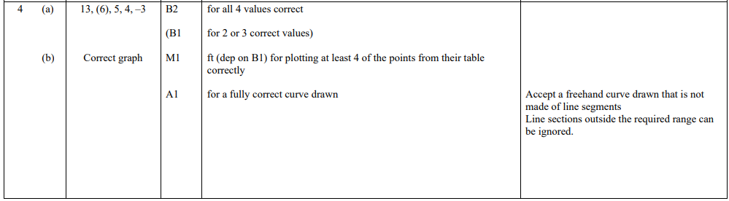
Pearson Edexcel - Thursday 6 June 2019 - Paper 2 (Calculator) Higher Tier
2.
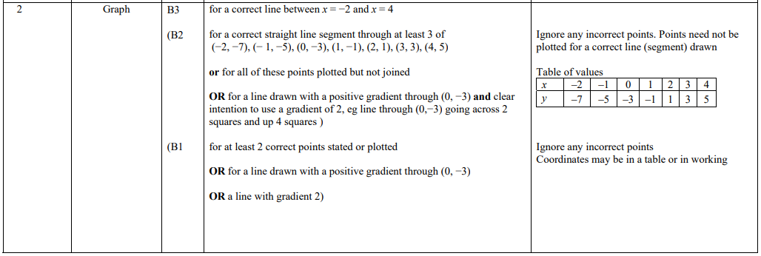
Pearson Edexcel - Tuesday 6 November 2018 - Paper 1 (Non-Calculator) Higher Tier
3.
Pearson Edexcel - Monday 12 November 2018 - Paper 3 (Calculator) Higher Tier
4.
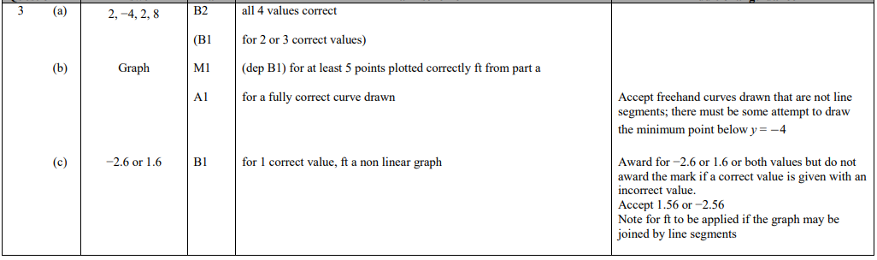
Pearson Edexcel - Monday 12 November 2018 - Paper 3 (Calculator) Higher Tier
5.
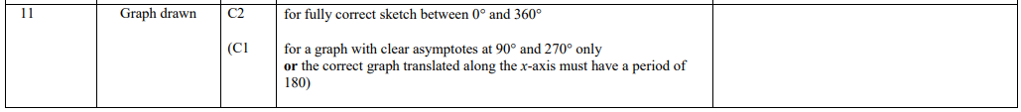
Pearson Edexcel - Thursday 24 May 2018 - Paper 1 (Non-Calculator) Higher Tier
6.
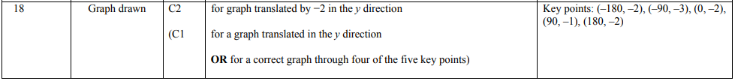
Pearson Edexcel - Thursday 7 June 2018 - Paper 2 (Calculator) Higher Tier
7.
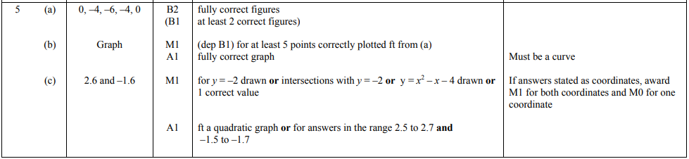
Pearson Edexcel - Thursday 7 June 2018 - Paper 2 (Calculator) Higher Tier
8.
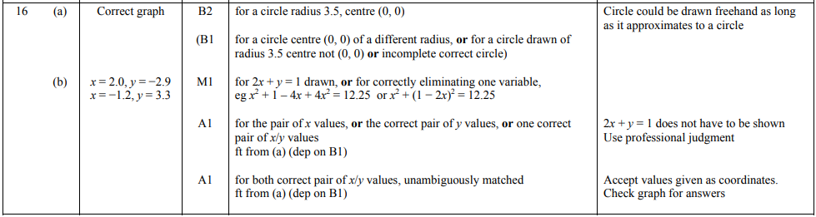
Pearson Edexcel - Thursday 2 November 2017 - Paper 1 (Non-Calculator) Higher Tier
9.
Pearson Edexcel - Monday 6 November 2017 - Paper 2 (Calculator) Higher Tier
10.
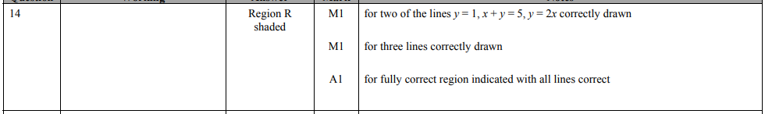
Pearson Edexcel - Specimen Papers Set 2 - Paper 2 (Calculator) Higher Tier
11.
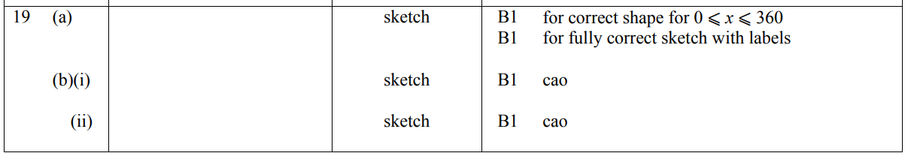
Pearson Edexcel - Specimen Papers Set 1 - Paper 2 (Calculator) Higher Tier
12.
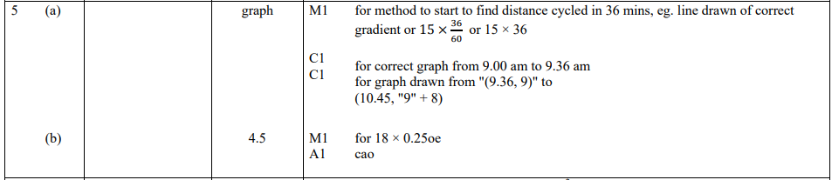
Pearson Edexcel - Sample Paper 2 - (Calculator) Higher Tier
13.
Pearson Edexcel - Sample Paper 3 - (Calculator) Higher Tier
14.
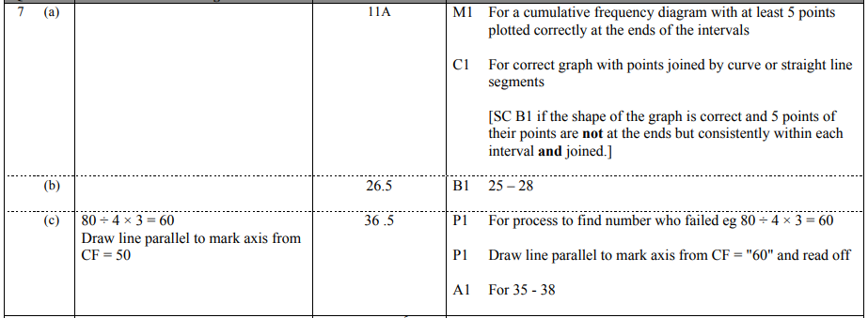
Pearson Edexcel - Sample Paper 3 - (Calculator) Higher Tier
15.
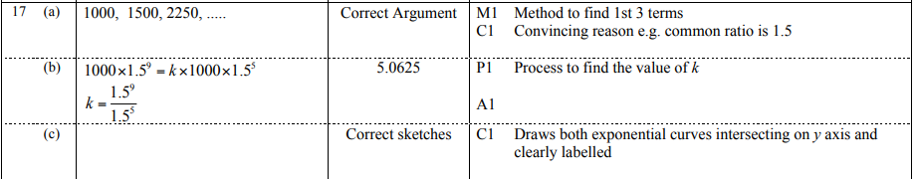
Pearson Edexcel - Thursday 9 June 2016 - Paper 2 (Calculator) Higher Tier
16.
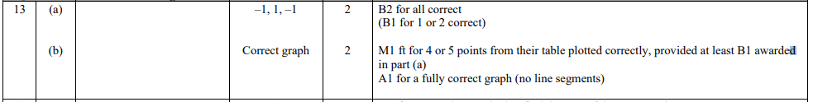
Pearson Edexcel - Wednesday 4 November 2015 - Paper 1 (Non-Calculator) Higher Tier
17.
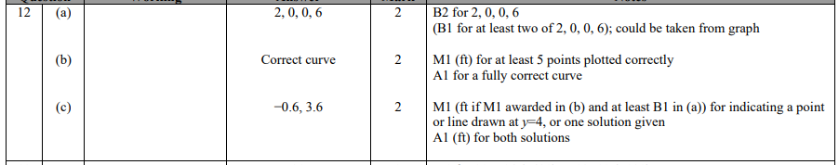
Pearson Edexcel - Wednesday 4 November 2015 - Paper 1 (Non-Calculator) Higher Tier
18.
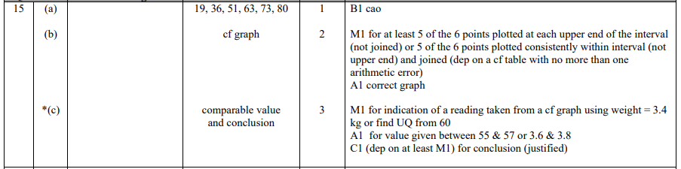
Pearson Edexcel - Friday 6 November 2015 - Paper 2 (Calculator) Higher Tier
19.
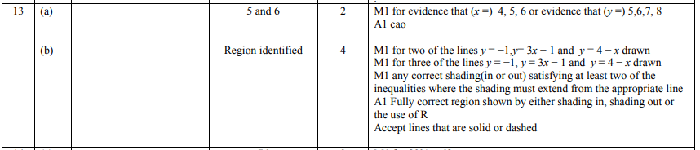
Pearson Edexcel - Friday 6 November 2015 - Paper 2 (Calculator) Higher Tier
20.
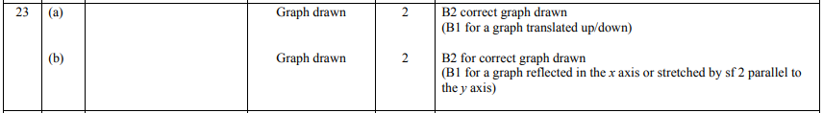
Pearson Edexcel - Monday 8 June 2015 - Paper 2 (Calculator) Higher Tier
21.
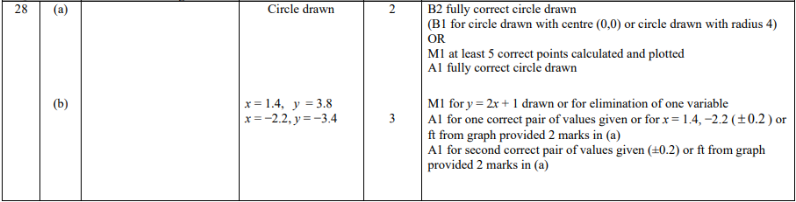
Pearson Edexcel - Wednesday 5 November 2014 - Paper 1 (Non-Calculator) Higher Tier
22.
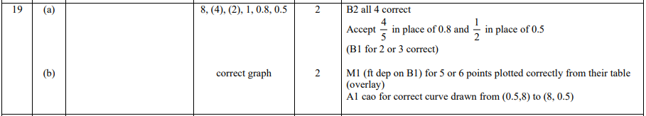
Pearson Edexcel - Friday 7 November 2014 - Paper 2 (Calculator) Higher Tier
23.
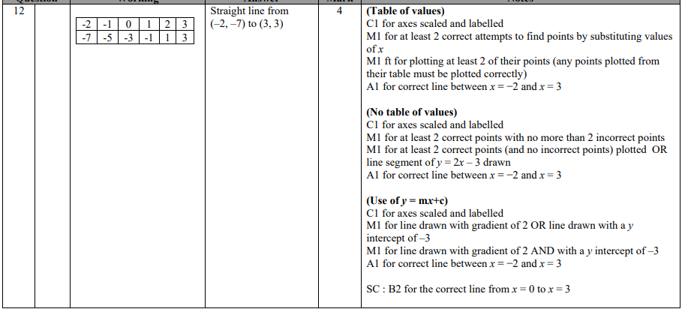
Pearson Edexcel - Monday 9 June 2014 - Paper 1 (Non-Calculator) Higher Tier
24.
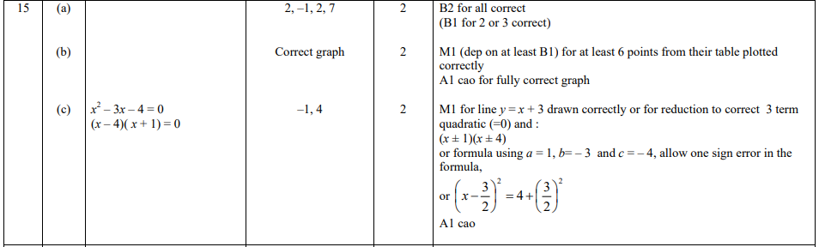
Pearson Edexcel - Wednesday 6 November 2013 - Paper 1 (Non-Calculator) Higher Tier
25.
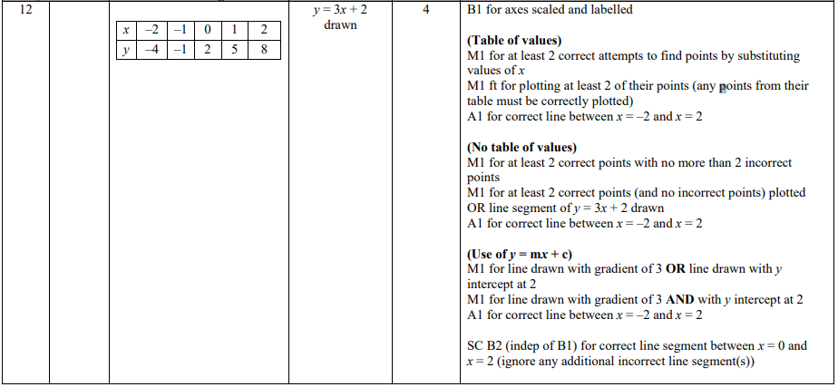
Pearson Edexcel - Friday 8 November 2013 - Paper 2 (Calculator) Higher Tier
26.
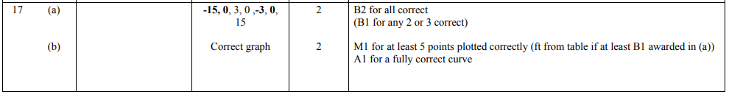
Pearson Edexcel - Tuesday 11 June 2013 - Paper 1 (Non-Calculator) Higher Tier
27.
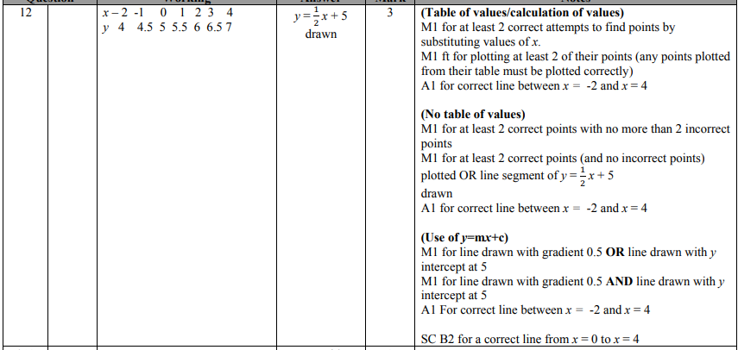
Pearson Edexcel - Friday 14 June 2013 - Paper 2 (Calculator) Higher Tier
28.
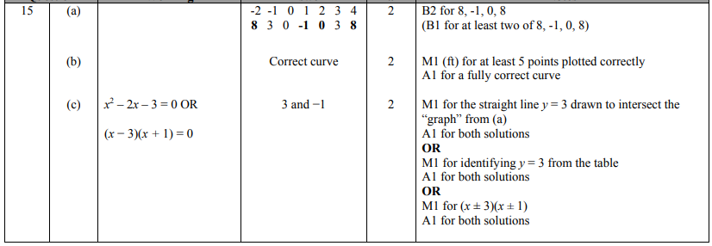
Pearson Edexcel - Thursday 28 February 2013 - Paper 1 (Non-Calculator) Higher Tier
29.
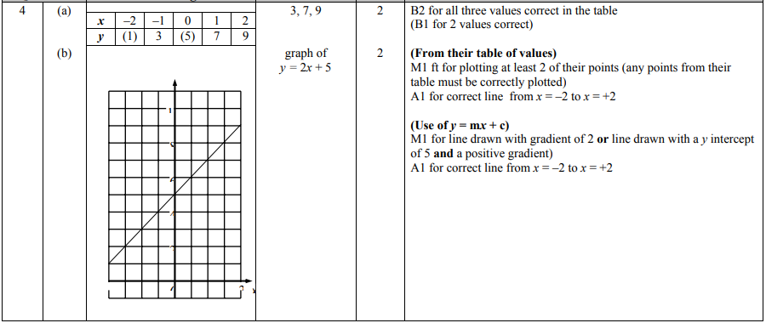
Pearson Edexcel - Thursday 28 February 2013 - Paper 1 (Non-Calculator) Higher Tier
30.
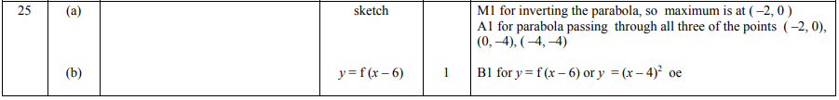
Pearson Edexcel - Tuesday 6 November 2012 - Paper 1 (Non-Calculator) Higher Tier
31.
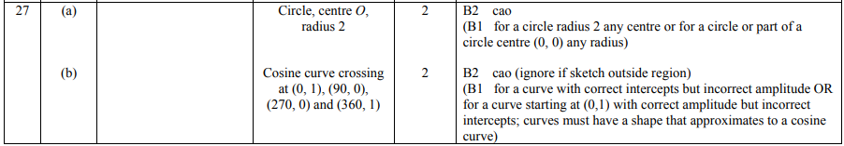
Pearson Edexcel - Thursday 8 November 2012 - Paper 2 (Calculator) Higher Tier
32.
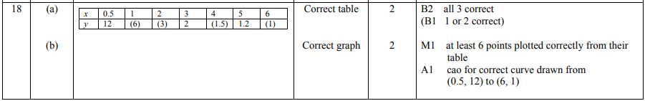
Pearson Edexcel - Monday 11 June 2012 - Paper 1 (Non-Calculator) Higher Tier
33.
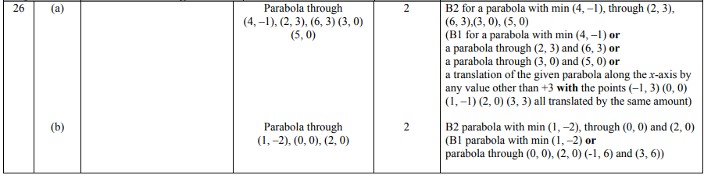
Pearson Edexcel - Wednesday 13 June 2012 - Paper 2 (Calculator) Higher Tier
34.
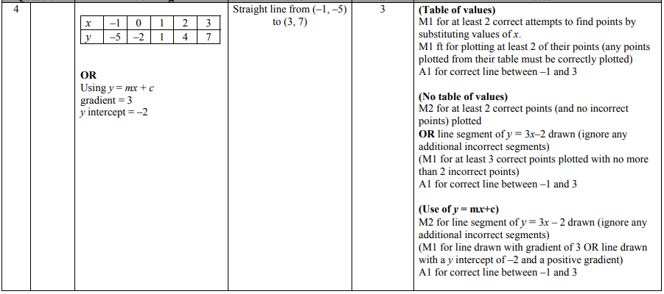
Pearson Edexcel - Friday 2 March 2012 - Paper 3 (Non-Calculator) Higher Tier
35.
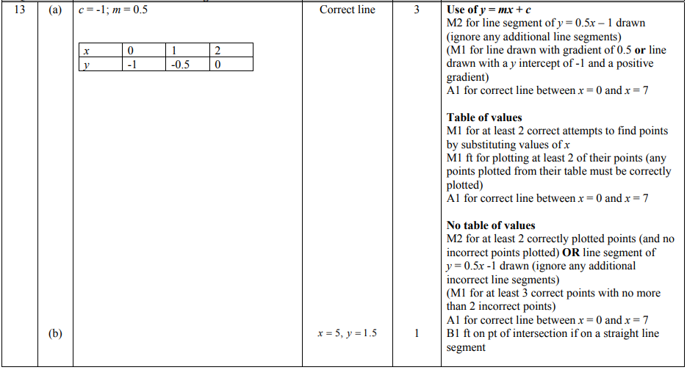
Pearson Edexcel - Monday 14 November 2011 - Paper 4 (Calculator) Higher Tier
36.
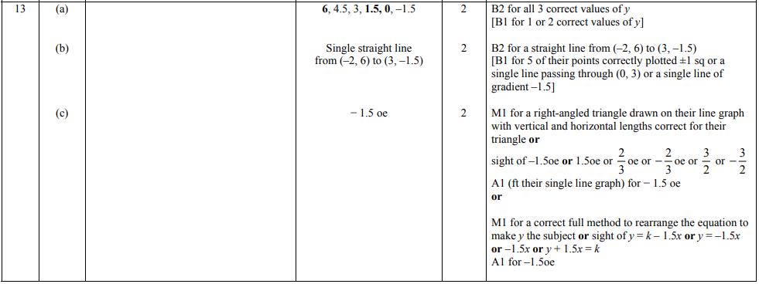
Pearson Edexcel - Friday 10 June 2011 - Paper 4 (Calculator) Higher Tier
37.
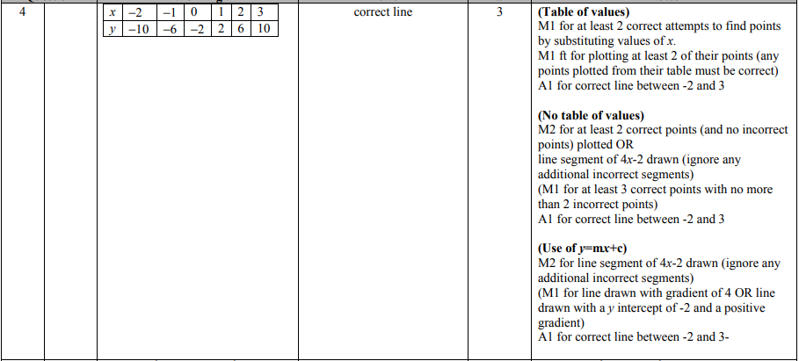
Pearson Edexcel - Tuesday 9 November 2010 - Paper 3 (Non-Calculator) Higher Tier
38.
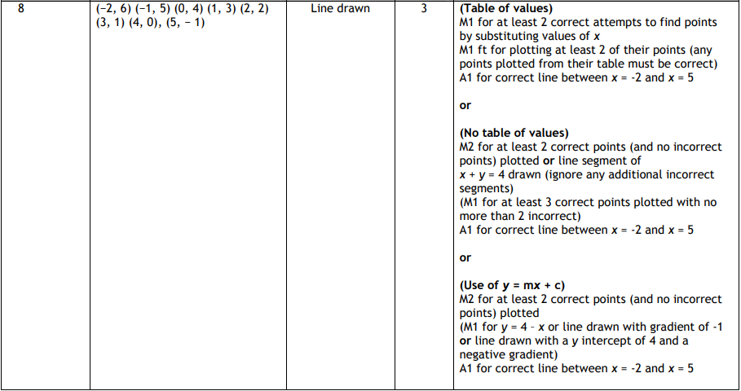
Pearson Edexcel - Tuesday 9 November 2010 - Paper 3 (Non-Calculator) Higher Tier
39.
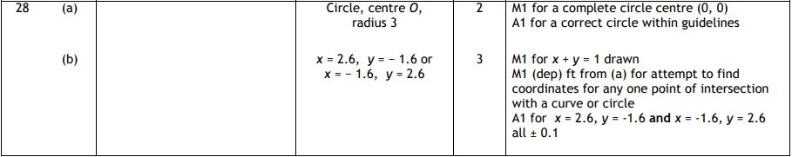
Pearson Edexcel - Friday 12 November 2010 - Paper 4 (Calculator) Higher Tier
40.
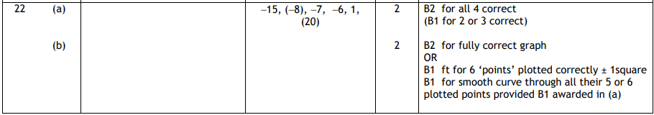
Pearson Edexcel - Friday 12 November 2010 - Paper 4 (Calculator) Higher Tier
41.
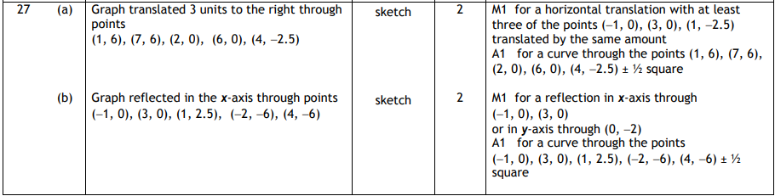
Pearson Edexcel - Monday 7 June 2010 - Paper 3 (Non-Calculator) Higher Tier
42.
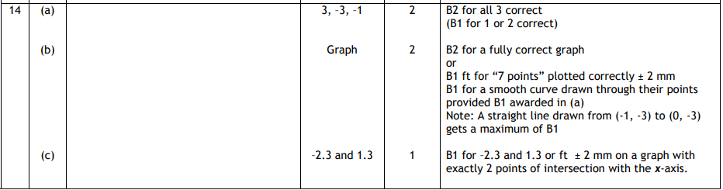
Pearson Edexcel - Friday 11 June 2010 - Paper 4 (Calculator) Higher Tier
43.
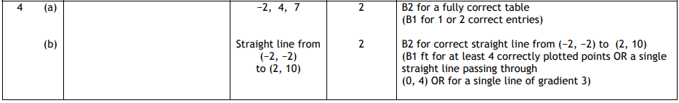
Pearson Edexcel - Friday 11 June 2010 - Paper 4 (Calculator) Higher Tier
44.
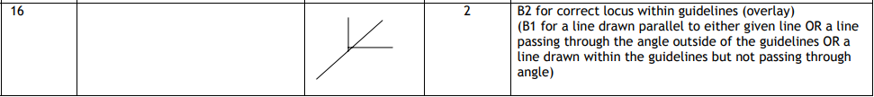
Pearson Edexcel - Thursday 5 November 2009 - Paper 3 (Non-Calculator) Higher Tier
45.
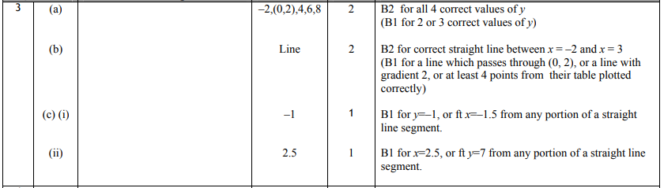
Pearson Edexcel - Tuesday 10 November 2009 - Paper 4 (Calculator) Higher Tier
46.
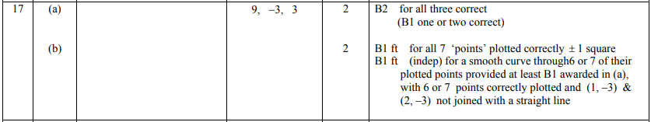
OCR GSCE – Thursday 5 November 2020 – Paper 5 (Non-Calculator) Higher Tier
47.
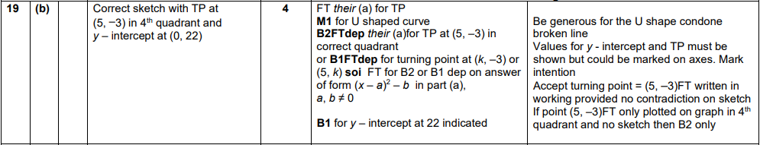
OCR GSCE – Tuesday 5 November 2019 – Paper 4 (Calculator) Higher Tier
48.
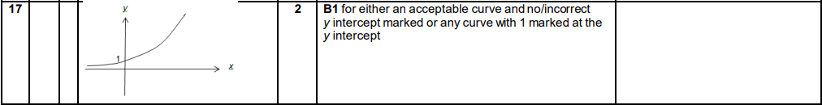
OCR GSCE – Thursday 7 November 2019 – Paper 5 (Non-Calculator) Higher Tier
49.
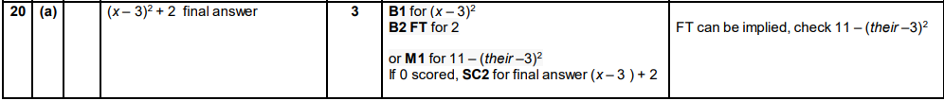
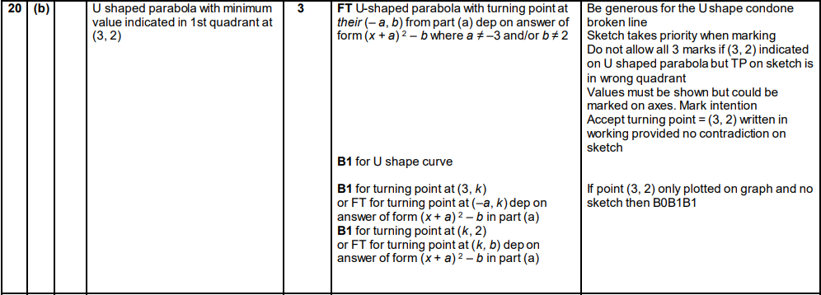
OCR GSCE – Monday 11 November 2019 – Paper 6 (Calculator) Higher Tier
50.
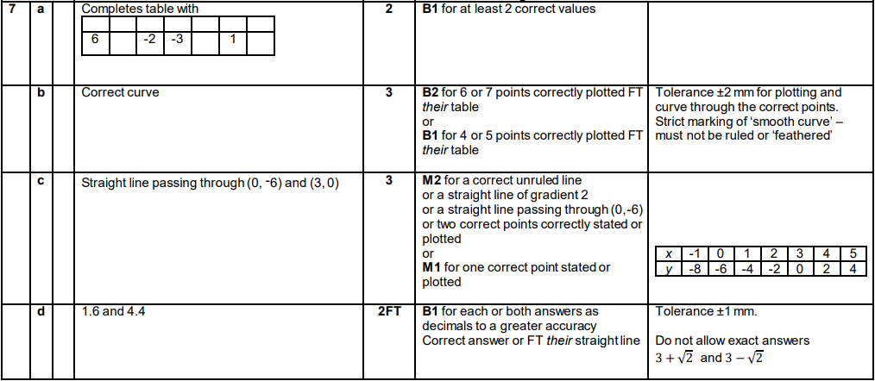
OCR GSCE – Thursday 6 June 2019 – Paper 5 (Non-Calculator) Higher Tier
51.
OCR GSCE – Thursday 6 June 2019 – Paper 5 (Non-Calculator) Higher Tier
52.
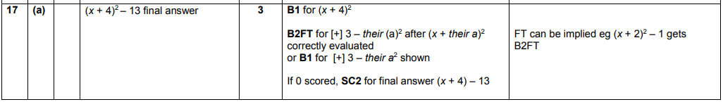
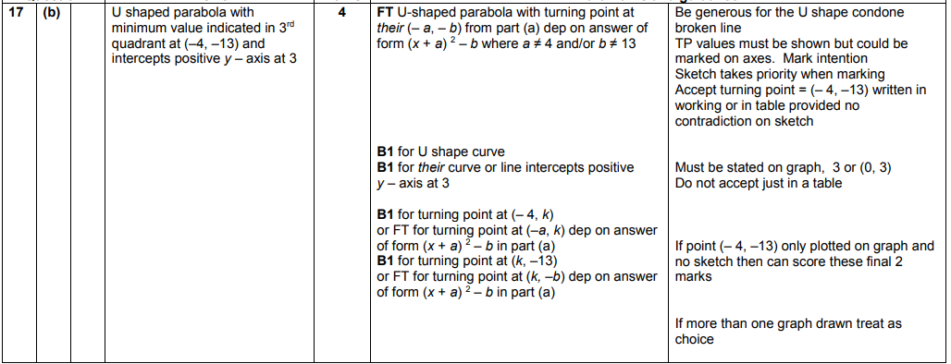

OCR GSCE – Tuesday 11 June 2019 – Paper 6 (Calculator) Higher Tier
53.
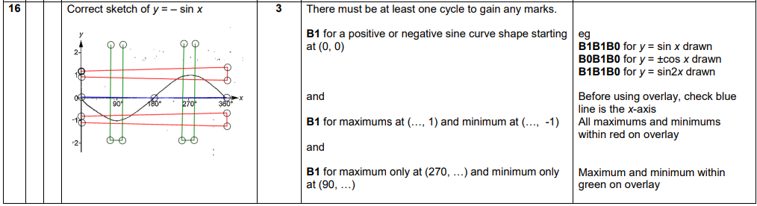
OCR GSCE – Tuesday 6 November 2018 – Paper 4 (Calculator) Higher Tier
54.
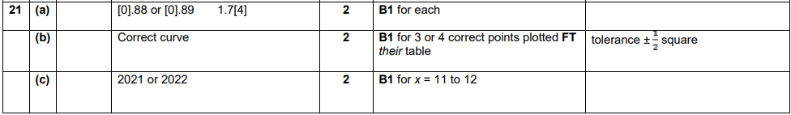
OCR GSCE – Thursday 8 November 2018 – Paper 5 (Non-Calculator) Higher Tier
55.
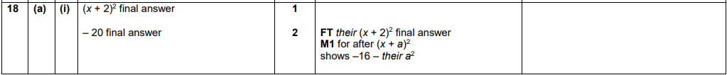
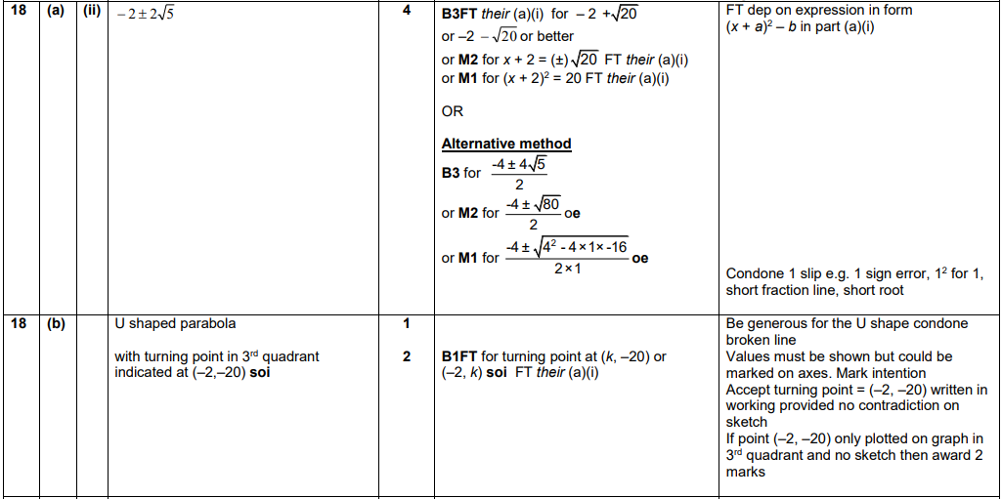
November 2018 – Paper 6 (Calculator) Higher Tier
56.
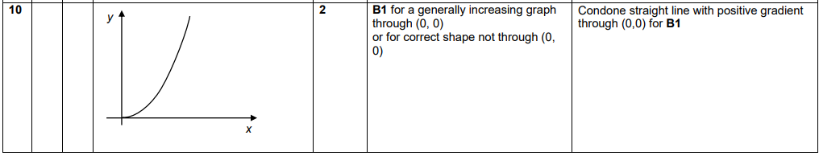
OCR GSCE – Monday 12 November 2018 – Paper 6 (Calculator) Higher Tier
57.
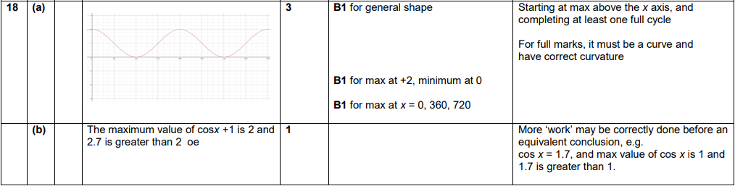
OCR GSCE – Thursday 24 May 2018 – Paper 4 (Calculator) Higher Tier
58.
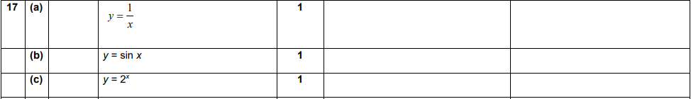
OCR GSCE – Thursday 7 June 2018 – Paper 5 (Non - Calculator) Higher Tier
59.
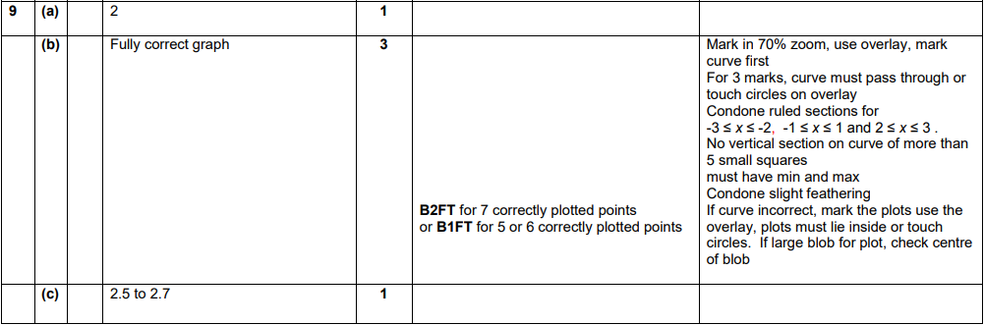
OCR GSCE – Tuesday 2 November 2017 – Paper 4 (Calculator) Higher Tier
60.
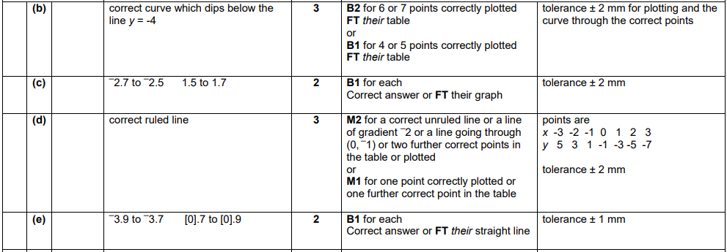
OCR GSCE – Tuesday 13 June 2017 – Paper 6 (Calculator) Higher Tier
61.
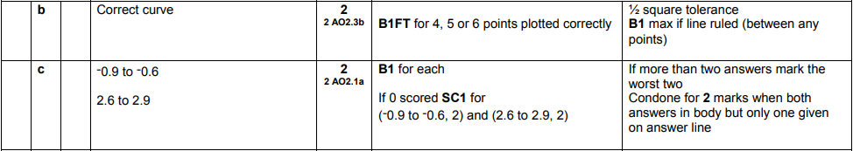
OCR GSCE – Tuesday 13 June 2017 – Paper 6 (Calculator) Higher Tier
62.
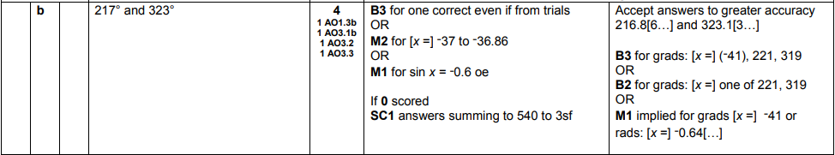

AQA GSCE – Tuesday 21 May 2019 – Paper 1 (Non - Calculator) Higher Tier
63.
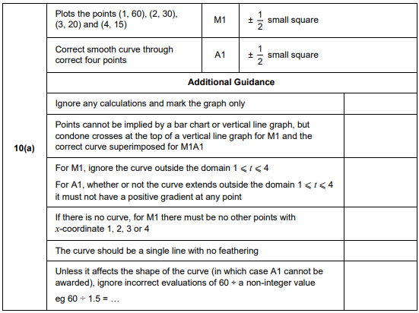
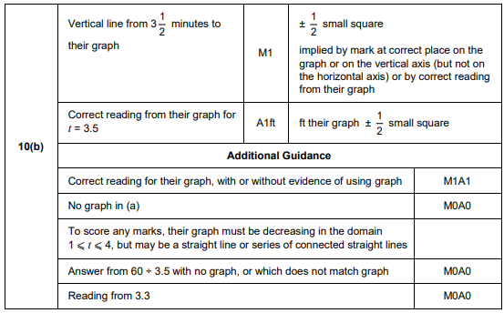

AQA GSCE – Thursday 6 June 2019 – Paper 2 (Calculator) Higher Tier
64.
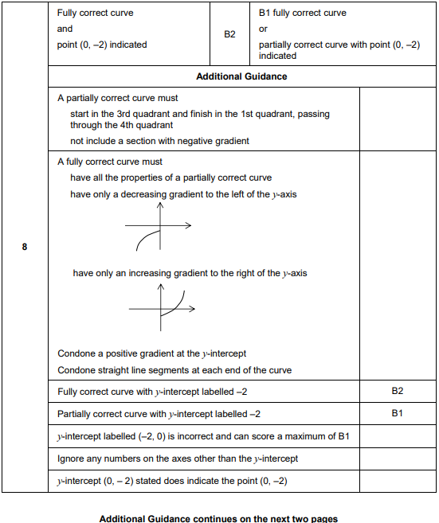
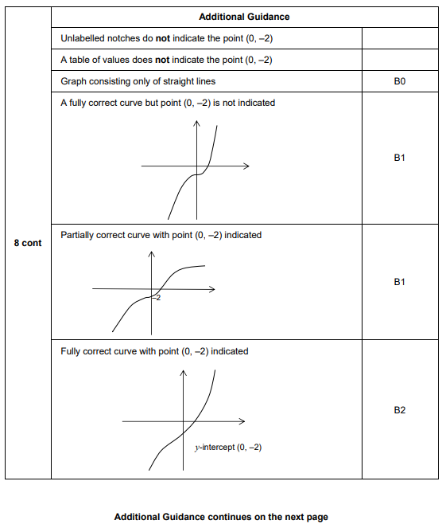
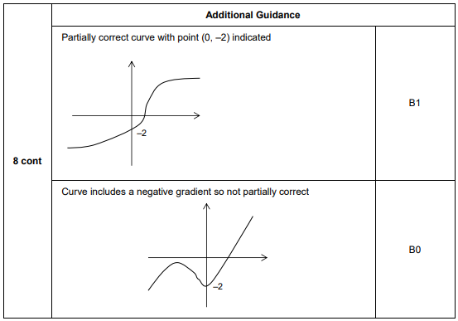

AQA GSCE – Thursday 8 November 2018 – Paper 2 (Calculator) Higher Tier
65.
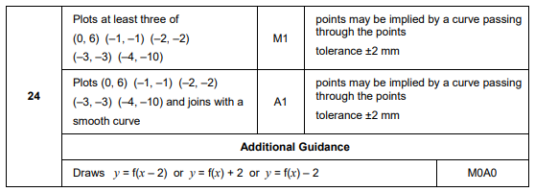
AQA GSCE – Tuesday 12 June 2018 – Paper 3 (Calculator) Higher Tier
66.
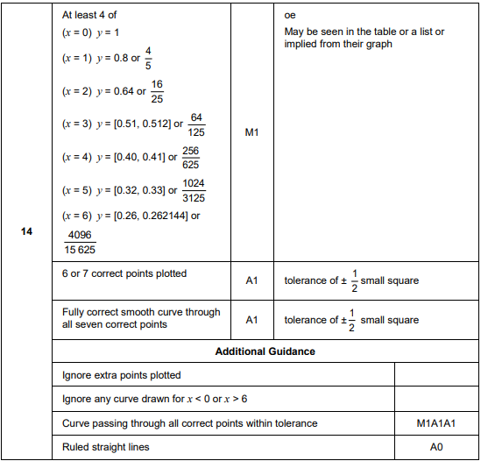
AQA GSCE – Thursday 8 June 2017 – Paper 2 (Calculator) Higher Tier
67.
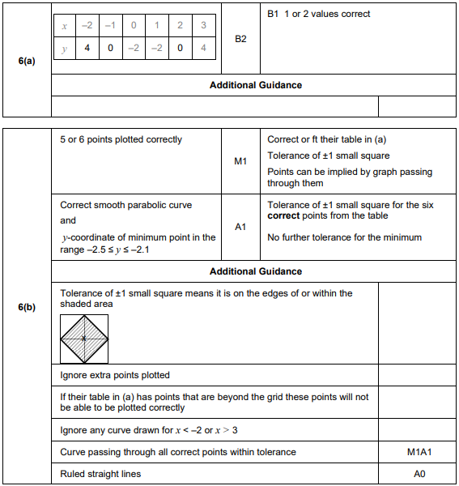
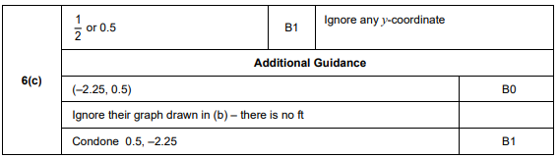

AQA GSCE – Thursday 8 June 2017 – Paper 2 (Calculator) Higher Tier
68.
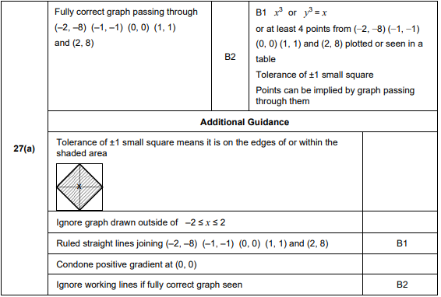
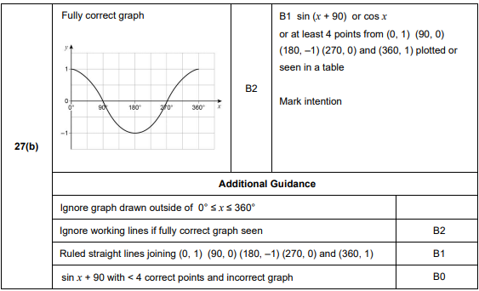

AQA GSCE – Sample Paper 2 (Calculator) Higher Tier
69.
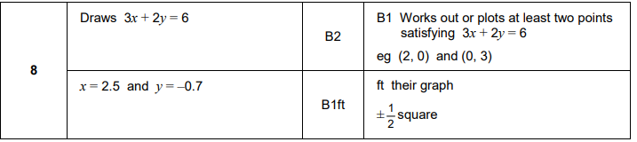
AQA GSCE – Sample Paper 3 (Calculator) Higher Tier
70.
